Gradient Descent
What is Gradient Descent?
- Gradient Descent is an optimization algorithm used to reduce the error (loss) of a deep learning model by updating model parameters (weights & bias) step by step.
- Minimize the loss function by finding the best weights.
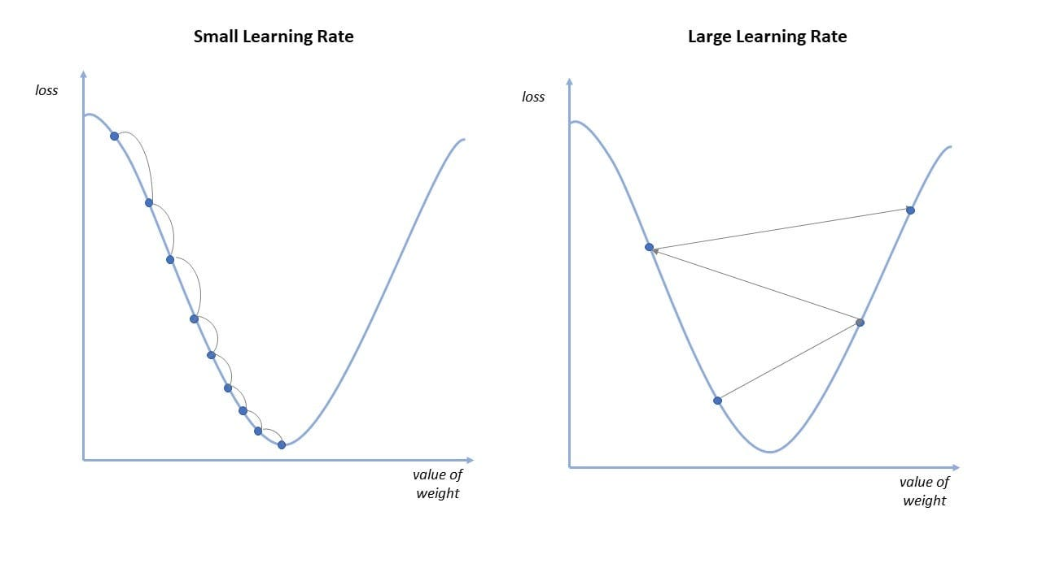

Why “Gradient”?
- Gradient = Direction of maximum increase of loss
- To reduce loss, we move in the opposite direction of gradient
👉 That’s why we use negative gradient

Mathematical Representation
Weight Update Rule
$$w=w-η\frac{∂L}{∂w}$$
Where:
- $w$= weight
- $η$= learning rate
- $L$= loss function
- $\frac{∂L}{∂w}$= gradient

Gradient Descent in Deep Learning (Step-by-Step)
Step 1: Initialize Weights
Random values
Step 2: Forward Propagation
- Input → Hidden layers → Output
- Calculate prediction
Step 3: Compute Loss
Example:
- MSE
- Cross-Entropy
Step 4: Backward Propagation
- Compute gradients using chain rule
- Find how much each weight contributed to error
Step 5: Update Weights (Gradient Descent)
- Move weights in direction of minimum loss
Step 6: Repeat
Until loss becomes minimum

Learning Rate (η)
What is Learning Rate?
Controls step size
- Too small → slow learning
- Too large → overshoot, divergence
📌 Typical values:
- 0.1
- 0.01
- 0.001

Loss Surface & Local Minima
- Global Minimum → Best solution
- Local Minimum → Sub-optimal
- Saddle Point → Flat region (common in deep networks)
Gradient Descent may get stuck → Optimizers help

MLP (ANN) gradient descent
- In an MLP, gradient descent is used to minimize the loss by updating weights and biases of all layers.
- After forward propagation computes the output and loss, backpropagation calculates gradients using the chain rule.
- Gradient descent then updates parameters in the opposite direction of the gradient, and this process is repeated over many epochs until the loss is minimized.

Why Gradient Descent is Required in MLP
- MLP has many weights & biases
- No closed-form solution
- Loss surface is non-linear & complex
Gradient Descent is used to minimize loss by updating all weights layer by layer

Training an MLP – Big Picture Flow
Input → Forward Propagation → Loss
↓
Backpropagation
↓
Gradient Descent Update
Gradient Descent is applied after backpropagation

Activation Function

What is an Activation Function?
An activation function is a mathematical function applied to a neuron’s output that decides whether the neuron should be activated or not.
Neuron Formula:
$$z=w_{1}x_{1}+w_{2}x_{2}+b \\ a=f(z)$$
Where:
- $z$→ weighted sum (linear)
- $f(z)$→ activation function
- $a$→ final output
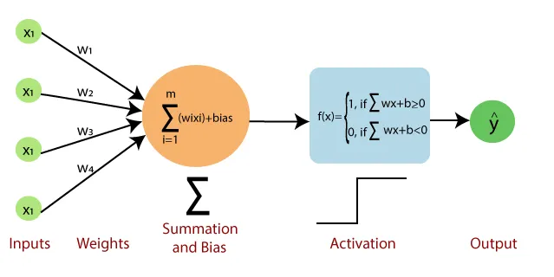

Why Activation Function is Needed
Without Activation Function:
- Network becomes purely linear
- Multiple layers behave like single layer
- Cannot learn complex patterns
📌 No activation function = No deep learning
If we don’t use activation functions, even a 100-layer neural network behaves like linear regression.

4. Linear vs Non-Linear Activation
Linear Activation
$$f(x)=x$$
- Straight line
- Cannot model complex data
Non-Linear Activation
- Curved graph
- Enables learning real-world patterns
📌 Deep learning works only because of non-linearity
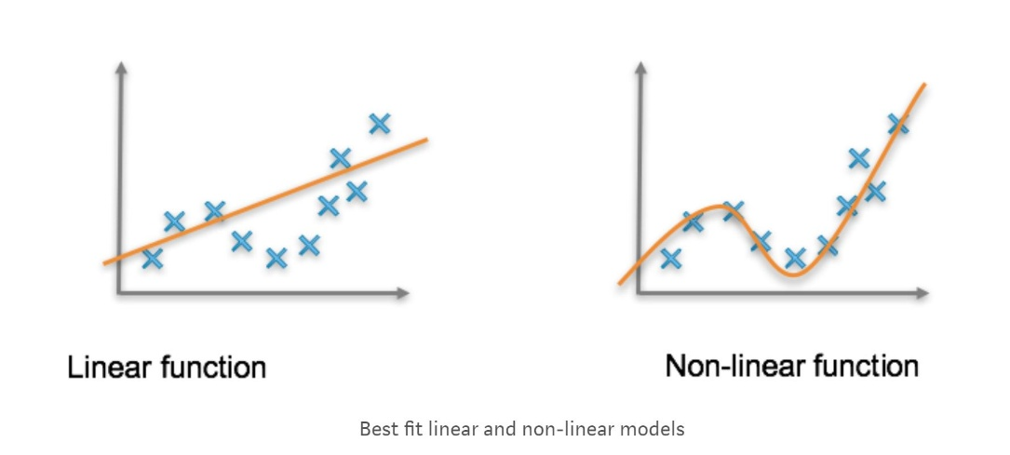

Types of Activation Functions
Broad Categories:
- Binary Activation
- Linear Activation
- Non-Linear Activation

Binary Step Activation Function
Formula:
$$f(x)=\left\{\begin{matrix}1, & x≥0 \\ 0, & x<0\end{matrix}\right.$$
Characteristics:
- Output: 0 or 1
- Used in Perceptron
Limitations:
❌ Not differentiable
❌ Gradient descent cannot be applied
📌 Not used in deep learning

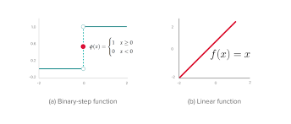
Linear Activation Function
Formula:
$$f(x)=x$$
Use Case:
✔ Output layer of regression models
Limitation:
❌ No non-linearity → weak learning power

Non-Linear Activation
Sigmoid Activation Function
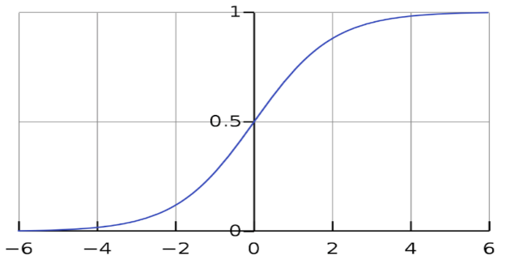
Formula:
$$σ(x)=\frac{1}{1+e^{-x}}$$
Output Range:
$\left(0 , 1\right)$
Advantages:
✔ Smooth
✔ Probability interpretation
Disadvantages:
❌ Vanishing gradient
❌ Slow training
📌 Used in binary classification output layer

Tanh Activation Function
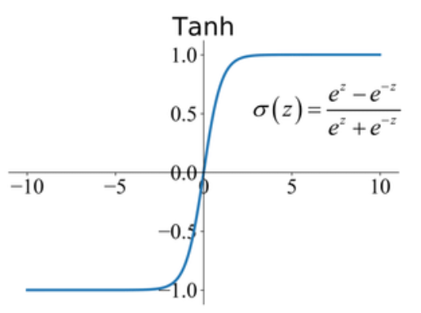
Formula: $tanh⁡(x)=\frac{e^{x}-e^{-x}}{e^{x}+e^{-x}}$
Output Range:$\left(-1,1\right)$
Advantages:
✔ Zero-centered
✔ Better than sigmoid
Still suffers:
❌ Vanishing gradient

ReLU (Rectified Linear Unit)
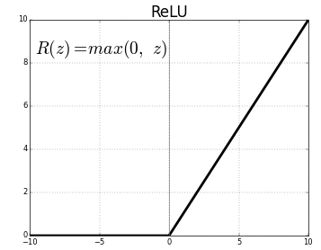
Formula:$f(x)=max⁡(0,x)$
Behavior:
- Positive → output same
- Negative → output zero
Advantages:
✔ Fast computation
✔ Reduces vanishing gradient
✔ Sparse activation

Problem:
❌ Dying ReLU (neuron stuck at 0)
📌 Default activation for hidden layers

ReLU Variants
Leaky ReLU
$$f(x)=\left\{\begin{matrix}x, & x>0 \\ 0.01x, & x≤0\end{matrix}\right.$$
✔ Fixes dying ReLU

Parametric ReLU (PReLU)
- Negative slope is learnable

ELU
- Smooth negative side
- Faster convergence

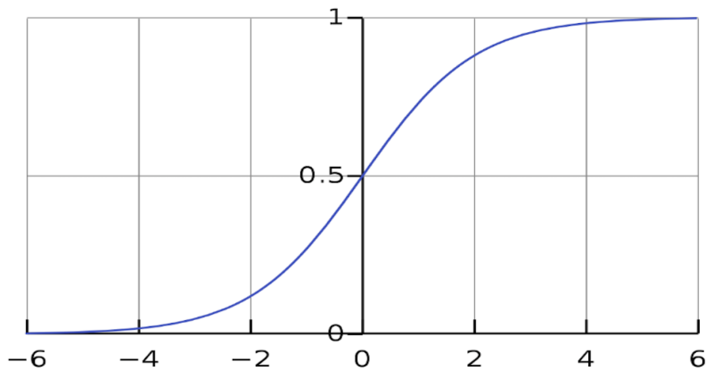
Softmax Activation Function
Formula:$f(z_{i})=\frac{e^{z_{i}}}{∑e^{z_{j}}}$
Properties:
- Output probabilities
- Sum of outputs = 1
Use Case:
✔ Multi-class classification
✔ Output layer

